Supply Chain Control Tower Architecture
Standard Operating Procedure (SOP): Building a Predictive Supply Chain Control Tower on AWS
Document ID: SOP-AWS-SCT-001
Version: 1.0
Effective Date: August 2026
Subject: End-to-End Implementation Guideline for Cloud Analytics, ML Inference, and Automated Alerting
1. Purpose & Scope
This Standard Operating Procedure defines the step-by-step process for provisioning, configuring, and operating a serverless Supply Chain Control Tower on Amazon Web Services (AWS). It establishes operational standards for ingesting SAP ERP datasets, setting up interactive SQL analytics, training predictive machine learning models for disruption forecasting, and executing automated event-driven alerting.

AWS Cloud Architecture & Machine Learning Pipeline

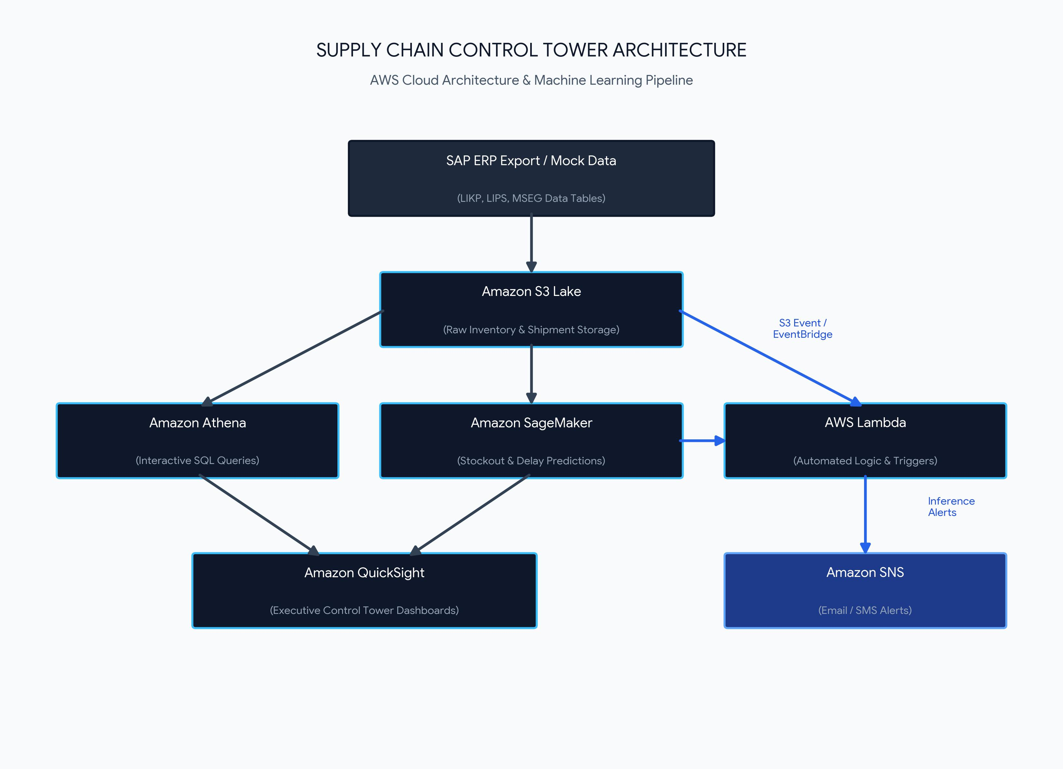

System Overview & Data Flow
This architecture demonstrates an end-to-end cloud data engineering and predictive machine learning pipeline for enterprise supply chain visibility and automated operational response.
Component | AWS Service | Operational Role
Data Ingestion | Amazon S3 | Centralized data lake for raw SAP ERP exports (LIKP, LIPS, MSEG tables).
Event Trigger | Amazon EventBridge / S3 Events | Captures data arrival events and triggers automated Lambda workflows.
Analytics Engine | Amazon Athena | Serverless interactive SQL queries directly against partitioned S3 data.
Machine Learning | Amazon SageMaker | Predictive models (XGBoost) for stockout and lead-time delay forecasting.
Automation Layer | AWS Lambda & Amazon SNS | Evaluates inference outputs and dispatches real-time alerts.
Visualization | Amazon QuickSight | Executive dashboards for operational KPIs, OTIF, and bottleneck monitoring.

1. Cloud Architecture & Technical Feasibility
Data Layer: Ingestion & Storage (SAP to S3)
- Implementation: Export SAP tables (e.g., LIKP/LIPS for delivery header/item data, MSEG/MKPF for inventory movement, VBAK/VBAP for sales orders) into CSV or Parquet files.
- Storage: Store raw data in an S3 Landing Bucket. Use AWS Glue Crawlers to automatically infer the schema and maintain the AWS Glue Data Catalog.
Analytics & Query Layer (Athena & QuickSight)
- Amazon Athena: Query structured S3 data using standard SQL without needing a persistent database server. Partition your S3 data by date (e.g., year=2026/month=08/) to optimize query speed and minimize costs.
- Amazon QuickSight: Connect QuickSight directly to Athena to build the front-facing Control Tower Dashboard. Key metrics to display include:
  - On-Time In-Full (OTIF) fulfillment rate.
  - Real-time inventory turnover and safety stock levels by SKU/facility.
  - Delayed shipment bottlenecks heatmaps.
AI/ML Layer (Amazon SageMaker)
- Stockout Prediction: Frame this as a binary classification or time-series forecasting problem (predicting demand vs. inventory trajectory over a $N$-day horizon). Algorithms like XGBoost or SageMaker Canvas / DeepAR work well here.
- Delivery Delay Prediction: Frame this as a regression model (predicting delay in days/hours) or classification model (Delayed vs. On-Time) using features such as carrier ID, origin/destination, order volume, and historical transit lead times.
Automation & Alerting (Lambda + SNS)
- Automated Workflow: Trigger an AWS Lambda function on a schedule (via Amazon EventBridge) or via S3 event notifications.
- Predictive Triggers: The Lambda function invokes the deployed SageMaker inference endpoint to evaluate current inventory and in-transit shipments. If predicted delay or stockout risk exceeds a set threshold, Lambda publishes a structured notification to Amazon SNS (email/SMS alerts) or a webhook (Slack/Teams).
2. Recommended Enhancements for Maximum Portfolio Impact
To ensure your project stands out to hiring managers and enterprise tech teams, consider adding the following components:
- Synthetic SAP Data Generation Script: Since real SAP data is proprietary, write a Python script (using pandas and faker) to generate realistic, schema-compliant SAP tables with realistic anomalies (e.g., sudden lead-time spikes or inventory supply shocks).
- Infrastructure as Code (IaC) or AWS CloudFormation/CDK: Store your AWS configuration in a version-controlled repository using CloudFormation templates or AWS CDK to prove cloud deployment fluency.
- Generative AI Assistant (Amazon Bedrock / Q): Enhance the control tower with a natural language interface (e.g., "Which facilities are at risk of stockouts next week?") using an Amazon Bedrock agent connected to your Athena data source.
3. Key Cost Management Practices
- Partition S3 Data: QuickSight queries against Athena can get costly if queries perform full table scans. Use Parquet format and partition data by date.
- SageMaker Serverless Inference: Instead of running a persistent $24/7$ SageMaker EC2 instance endpoint, use SageMaker Serverless Inference or batch transform jobs to process predictions only when triggered.
- QuickSight Author Licenses: Shut down or convert active author licenses when not in use during testing phases.

